Welcome Club

March 26 2021~ 3:30pm-4:30pm

 Character lesson of the month:

Perseverance- accepting decisions of authorities

* Keep going, even when it’s hard

**3:30-3:35**

Introduction to Welcome Club  - (Coach Megan)

-Build friendships

-Help each other

-Discuss problems and issues with coaches and students

-Have fun!

 *Review Welcome club’s foundation for how we treat each other: Treat others the way you want to be treated.

-**Transition**- (Coach DeVon) “Ok let’s have the coaches introduce themselves and tell us how many brothers and sisters they have?”

**3:35-3:45**

 Introduction of Coaches- We will take turns sharing our name and sharing about their siblings.

-**Transition**- (Coach Amy) “Now I want to introduce our lesson for today.” Accepting decisions of authority

Introduction of Character Lesson- “Today we are going to talk about perseverance- accepting decisions of authority.

-**Transition**- (Coach Marina) “Let’s get into our breakout rooms and we can start with a game! Everyone make sure you have your Welcome Club bag and markers or crayons.”

**3:45-4:00**

- Coaches, start your group time by having each student introduce himself or herself and share what color they feel like today. Next, you will need to explain the rules of the game. Assistant coaches are encouraged to participate.

ICEBREAKERS  - Pictionary

Directions: In this version of Pictionary coaches will be drawing authority figures while students guess. Coaches will use a piece of paper and a black marker to draw 5-9 different people of authority. Students can either raise their hand to be called on or type their guess in the chat. Authority figures to draw: mom, dad, teacher, coach, principal, older siblings, grandparents (older members of their community), tutors, apartment manager. We are focusing on authority figures the students would have a relationship with not a neighborhood authority like a firefighter.

**-Transition-** (coaches) “Good guessing! Let’s talk more about authority”.

**4:00-4:15**

 Lesson:    Perseverance- accepting decisions of authority

Coaches:

“All of these people are people that you know who have authority. They set up rules and guidelines for you and others. What does authority mean? Authority means- People who have the power to make rules and decisions. Sometimes we can have a hard time following the rules that people in authority make. Like when your mom tells you no playing video games until your schoolwork is done. Who can give us another example of a person with authority making a rule or a decision? *Students can give several examples.*

Sometimes we don’t feel like we want to follow those decisions. This is when we need to think about lemons! Lemons can help us remember to have a good attitude. In the USA we have a saying, “when you get lemons make lemonade”. Lemons are very sour. Who has eaten a lemon before? It can be so sour. In your goody bag is a sour straw. Everyone get out your sour straw and take a bite. It is so sour! Lemons are like that. When we mix lemons with water and sugar we make a sweet drink, lemonade. Everyone get out your water bottle from your bag and the lemonade pack. Mix the lemonade with the water and take a drink. It should be sweet. If we have a bad attitude we will have a hard time following the decision made by authority. But if we have a good attitude it’s like adding sugar to lemons and making lemonade. We will have an easier time listening to people of authority like teachers and coaches and understand why they are giving us rules to follow when we have a good attitude.

You all have great minds! You are all very smart. We don’t want you to just blindly follow what every older person tells you to do. It’s important to think about who is the authority and what they are asking you to do. You can ask yourselves, “does this person of authority care about me?” “Is this person of authority telling me to do something safe? “Is this person of authority asking me to do something that could hurt me?” People like your mom, dad, coach, and teacher are all people of authority who you know and have a relationship with. Think through what the authority is saying and asking you to do”.

**Transition**- “We are going to make a craft to show us how our attitude can help us when we are having a hard time following decisions of authority”.

**4:15-4:30 Activity- Spinners**

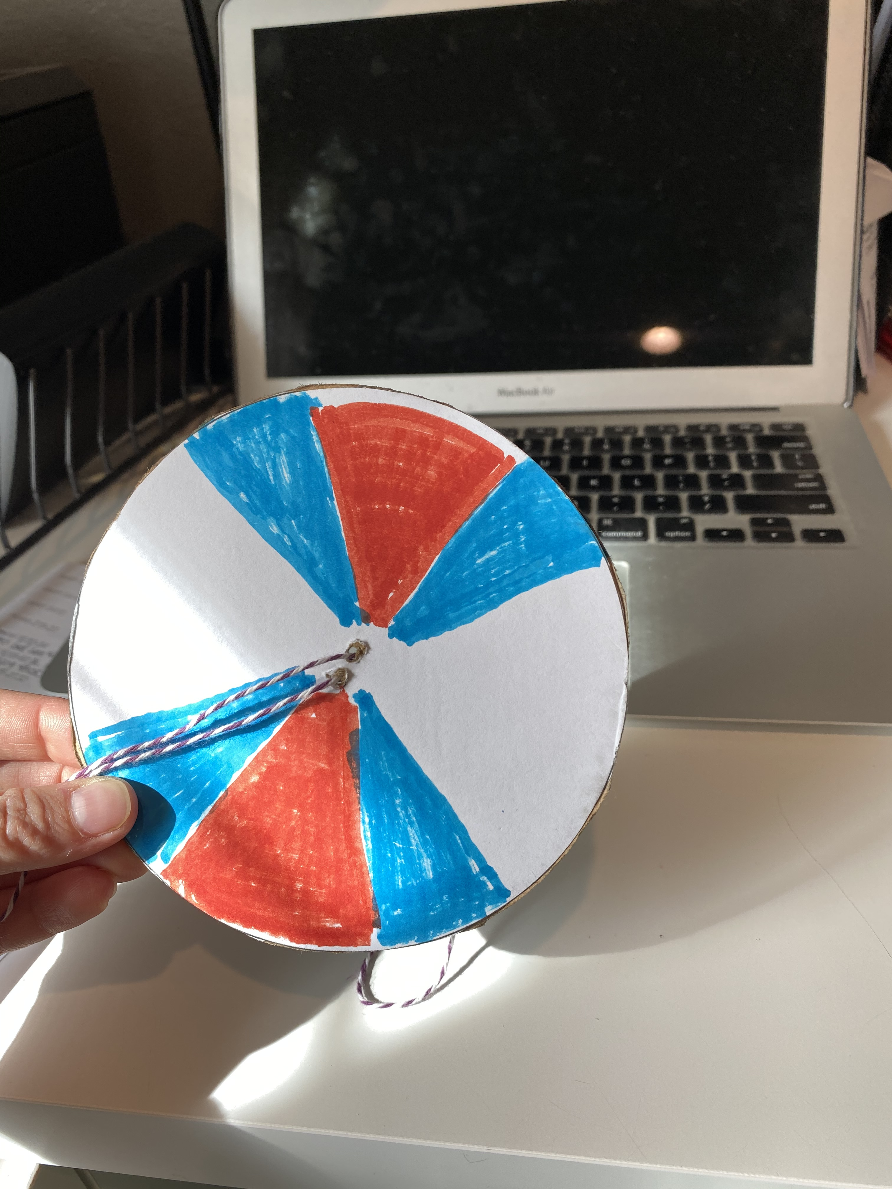

<https://www.youtube.com/watch?v=bZ8PShMOXps>

We will be making spinners. Each student will have the cardboard spinner circle and string. The students will use lemon stickers to decorate one side of the spinner and use crayons or markers to decorate the other side. We will be using color theory as another example of how attitude can change a sour situation. Color theory- primary colors like blue and yellow when mixed make green.

Students are encouraged to use a primary color (yellow, red, blue) in a pattern (swirls, dots, circles, squares, rectangles, triangles). When the spinner is moving secondary colors will show. Watch short video from link above for more information.

Discussion points while completing spinner-

-How does color theory remind us how a good attitude can help when authority makes decisions we might not like? (Two primary colors side by side will mix when spinning and look like a different color. This can remind us to keep a good attitude and try to put yourself in the person of authorities shoes and why they might be making that decision or rule.)

-How do lemons help us remember to keep a good attitude when authorities make decisions that we don’t like? (Lemons are sour and sometimes we don’t like a decision an authority makes and that can be “sour”. If we have a good attitude it can help us make a “sour” time sweet like adding sugar to lemons and making lemonade).

-Should we follow decisions authorities make without thinking about why the authority is making that decision? No, we should always think, “is this safe, is this good for me, can I trust this person, does this person have my best interests at heart?”

Conversation starters and fun question ideas- Would you rather…

1. Swim in a pool of jello or swim in a pool of pudding?
2. Have a pet dinosaur or a robot?
3. Have to swim the entire day or stay still the entire day?
4. Be an eagle or a cheetah?
5. Ride on a whale or an elephant?
6. Be the size of an ant or be the size of a house?
7. Live fifty feet up in tree or live in a cave underground?
8. Be older or younger?
9. Visit China or England?
10. Have cotton balls for hair or hairbrush for teeth?
11. Have butterfly wings or fish fins?
12. Have a pink cat or a flying horse?

**4:30**

 Wrap up and Goodbyes

* Updates and information- (Coach Makayla)
* Tutoring- Thursday 2:30pm  Reading pod- Monday 3:30(Coach Megan/Makayla)

**\*Coaches stay on for quick debrief**